Module 4 - Test driven development and Logging framework

JUnit_Basic Testing Exercises:

Exercise 1: Setting Up Junit
Program Code:

package com.example.JUnitDemo;

import static org.junit.Assert.assertEquals;
import org.junit.Test;

public class CalculatorTest {

@Test
public void testAddition() {
assertEquals(5, 2 + 3);
}
}

Output:
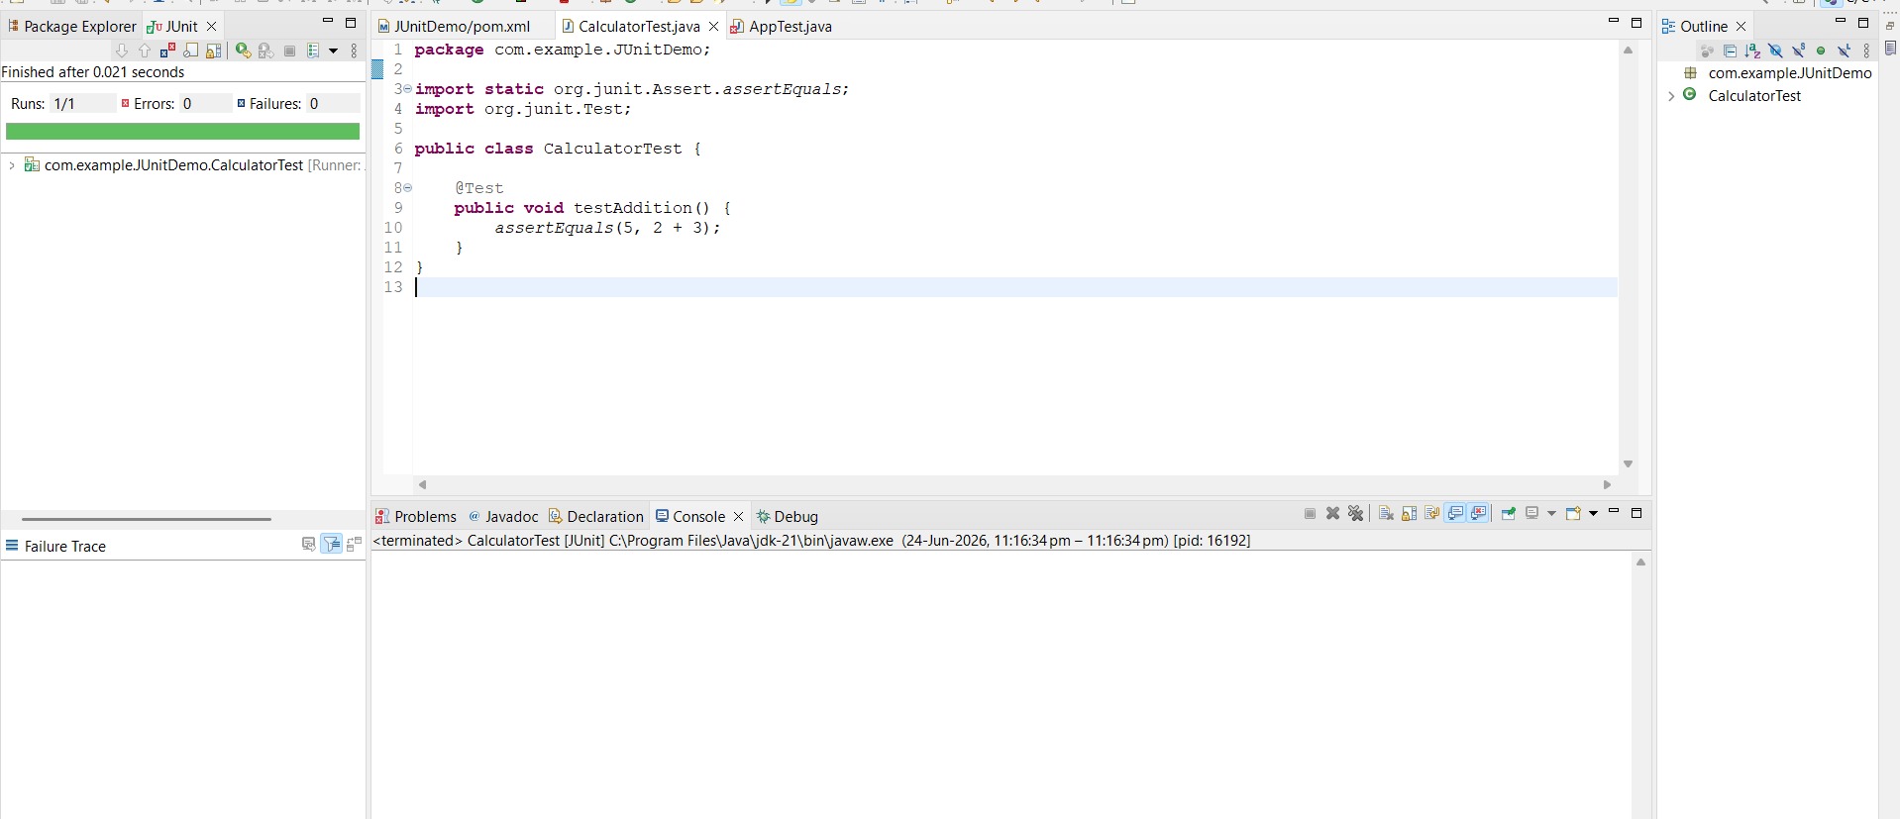

Exercise 3: Assertions in Junit:
Program Code:

package com.example.JUnitDemo;
import static org.junit.Assert.*;
import org.junit.Test;

public class AssertionsTest {

@Test
public void testAssertions() {

// Assert Equals
assertEquals(5, 2 + 3);

// Assert True
assertTrue(5 > 3);

// Assert False
assertFalse(5 < 3);

// Assert Null
assertNull(null);

// Assert Not Null
assertNotNull(new Object());
}
}

Output:
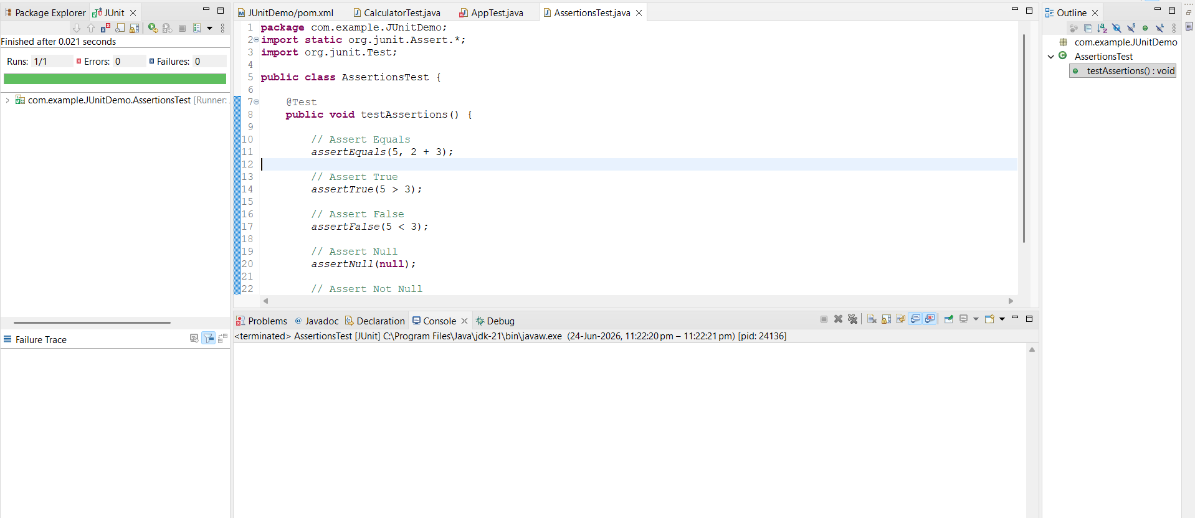

Exercise 4: Arrange-Act-Assert (AAA) Pattern, Test Fixtures, Setup and Teardown Methods in JUnit
Program Code:

package com.example.JUnitDemo;

import static org.junit.Assert.assertEquals;
import org.junit.After;
import org.junit.Before;
import org.junit.Test;

public class AAATest {

private int num1;
private int num2;

@Before
public void setUp() {
num1 = 10;
num2 = 20;
System.out.println("Setup Method Executed");
}

@Test
public void testAddition() {

// Arrange
int expected = 30;

// Act
int actual = num1 + num2;

// Assert
assertEquals(expected, actual);

System.out.println("Test Method Executed");
}

@After
public void tearDown() {
System.out.println("Teardown Method Executed");
}
}

Output:
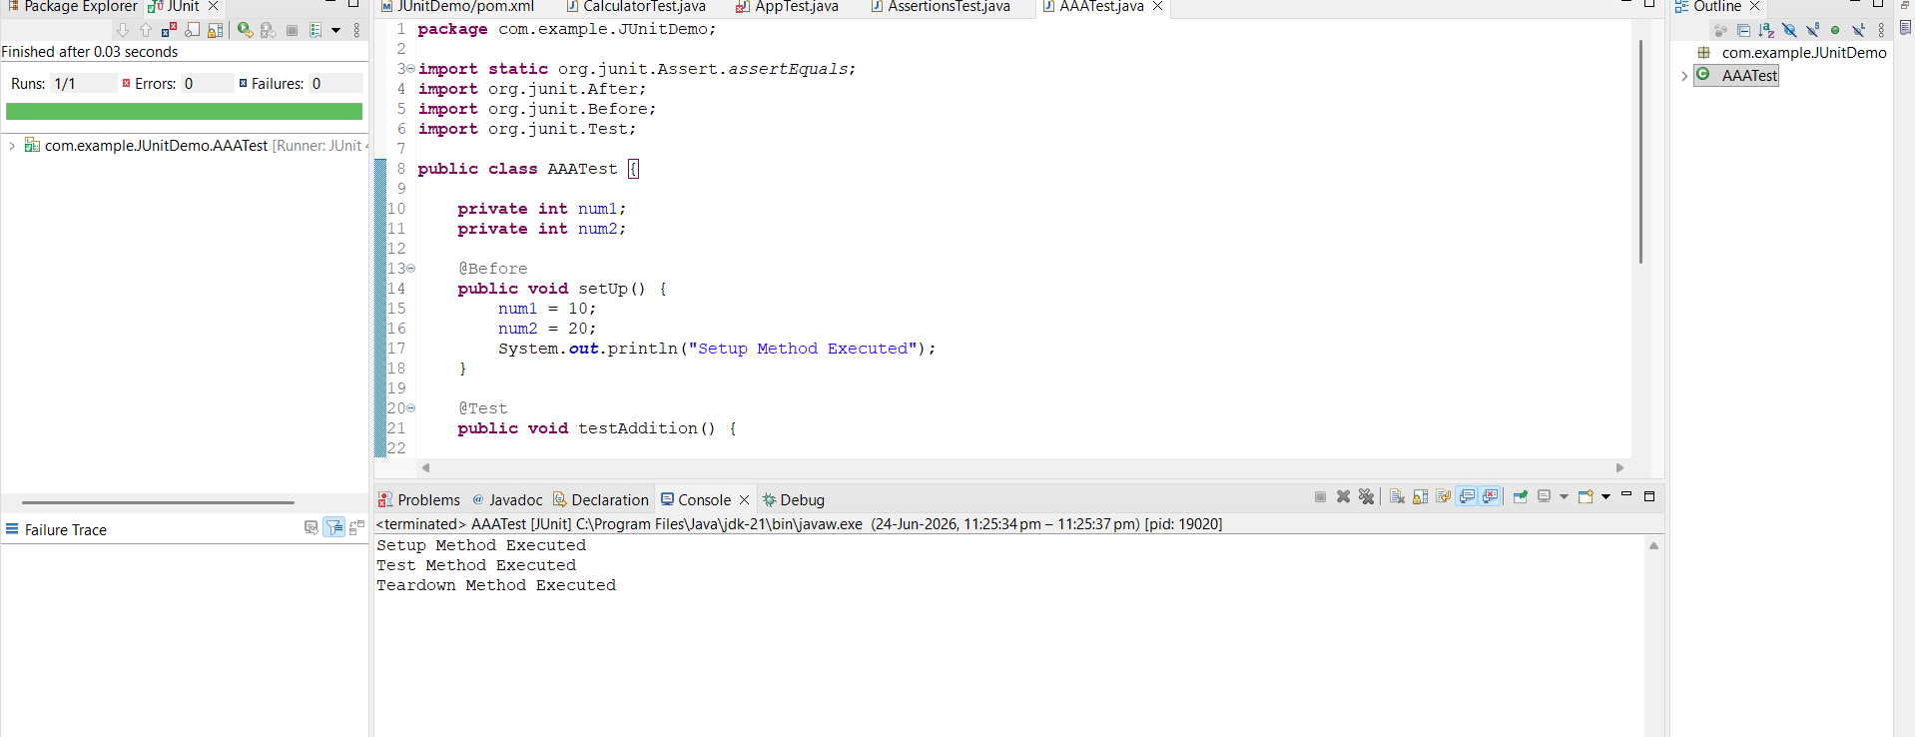

Mockito exercises:
Exercise 1: Mocking and Stubbing
Program Code:

ExternalApi.java
package com.example.JUnitDemo;

public interface ExternalApi {
String getData();
}

MyService.java:
package com.example.JUnitDemo;

public class MyService {

private ExternalApi api;

public MyService(ExternalApi api) {
this.api = api;
}

public String fetchData() {
return api.getData();
}
}

MyServiceTest.java
package com.example.JUnitDemo;

import static org.junit.jupiter.api.Assertions.assertEquals;
import static org.mockito.Mockito.when;

import org.junit.jupiter.api.Test;
import org.mockito.Mockito;

public class MyServiceTest {

@Test
public void testExternalApi() {

// Create mock object
ExternalApi mockApi = Mockito.mock(ExternalApi.class);

// Stub method
when(mockApi.getData()).thenReturn("Mock Data");

// Inject mock into service
MyService service = new MyService(mockApi);

// Call method
String result = service.fetchData();

System.out.println(result);

assertEquals("Mock Data", result);

// Verify result
assertEquals("Mock Data", result);
}
}

Output:

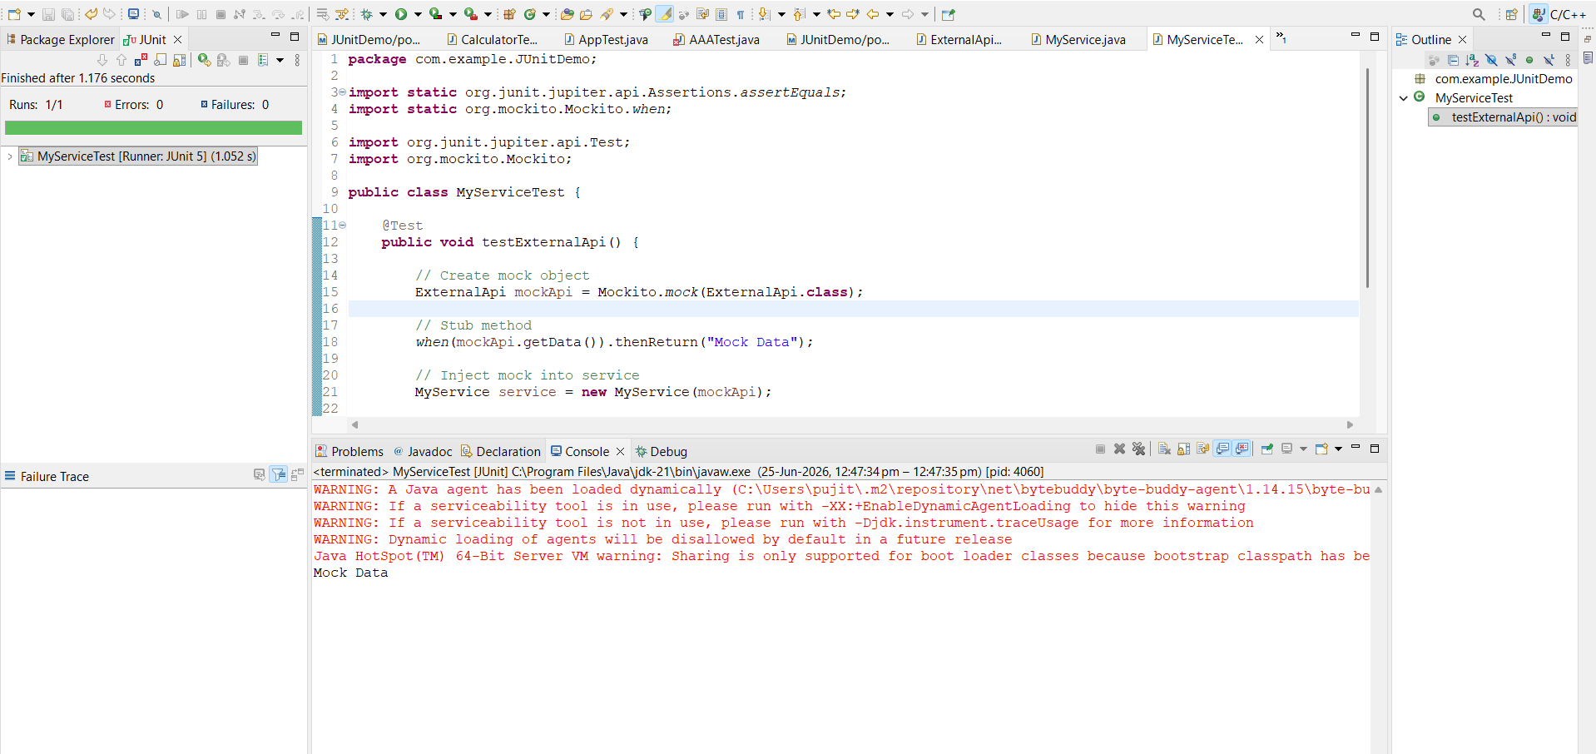

Exercise 2: Verifying Interactions
Program Code:

Test Class:
package com.example.JUnitDemo;

import static org.mockito.Mockito.verify;

import org.junit.jupiter.api.Test;
import org.mockito.Mockito;

public class MyServiceTest1 {

@Test
public void testVerifyInteraction() {

// Create mock object
ExternalApi mockApi = Mockito.mock(ExternalApi.class);

// Create service
MyService service = new MyService(mockApi);

// Call method
service.fetchData();

// Verify interaction
verify(mockApi).getData();
}
}

Output:
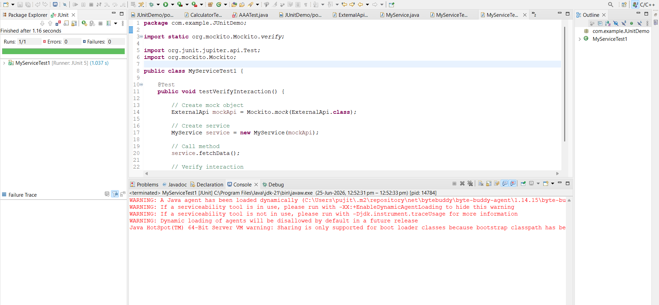

SL4J Logging exercises
Exercise 1: Logging Error Messages and Warning Levels
Program Code:

LoggingExample.java
package com.example.JUnitDemo;

import org.slf4j.Logger;
import org.slf4j.LoggerFactory;

public class LoggingExample {

private static final Logger logger =
LoggerFactory.getLogger(LoggingExample.class);

public static void main(String[] args) {

logger.error("This is an error message");

logger.warn("This is a warning message");

}
}

Output:
